**Rolling Element Fault Diagnostics**

**Outer Race Fault Bearing Vibration Analysis:**

**Increasing Speed:**

**Dataset #1:**

**Full Time Duration**

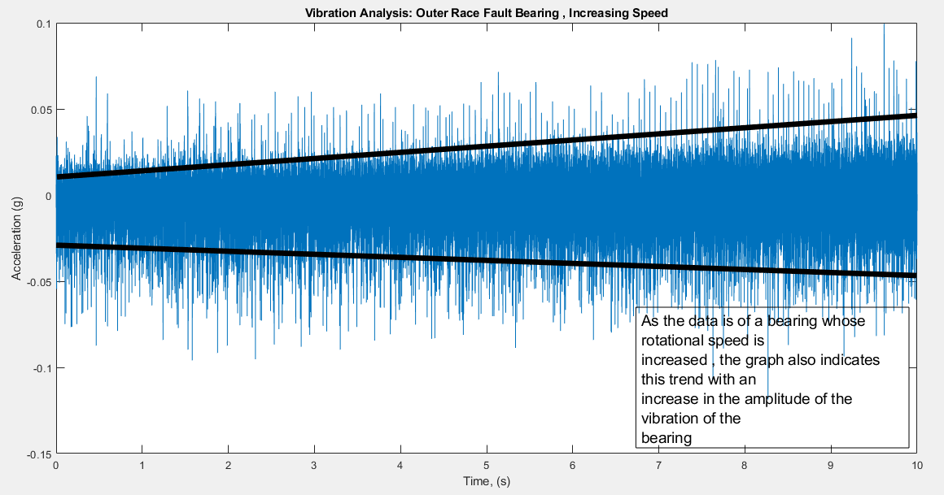

The rotational speed is increased from 14.1 Hz to 23.8 Hz which is almost 2 times increase, this increase is shown in the above graph as well which shows that the amplitude has almost achieved two-fold increase.

**Zoomed In View of the Above Graph :**

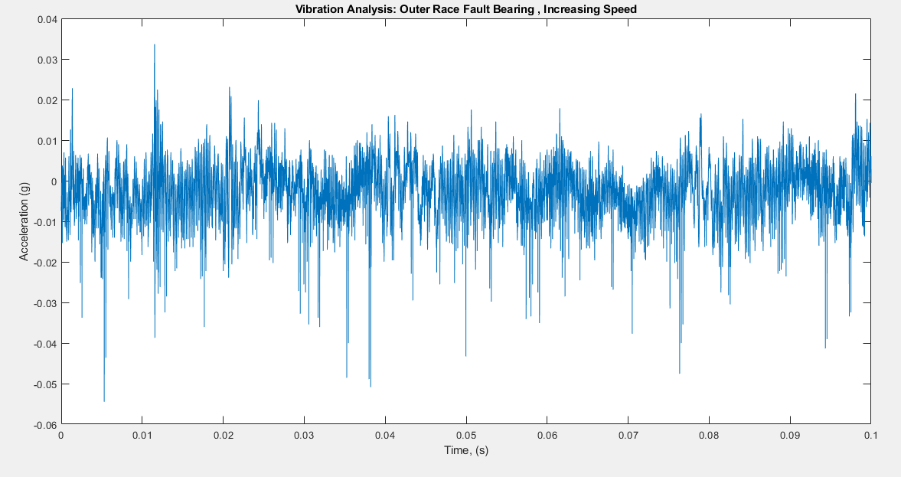

The above graph shows a zoomed in view of the time domain waveform of the bearing with outer race fault. As we can see from this graph that the wave form in this is highly irregular and with numerous peaks. These peaks are not to be found in the zoomed in view of the time domain waveform of the healthy bearing.

**Fourier Spectrum**

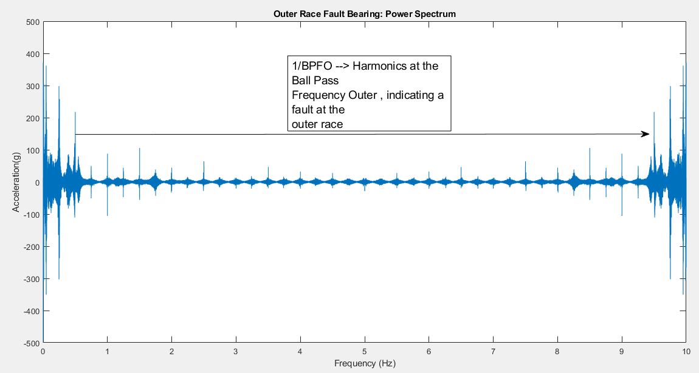

The above graph is Fast Fourier Transform of the bearing signal which shows peaks at the Ball Pass outer frequencies. These frequencies are basically an indication of harmonics at these points or locations on these bearings.

**Envelope Spectrum Analysis**

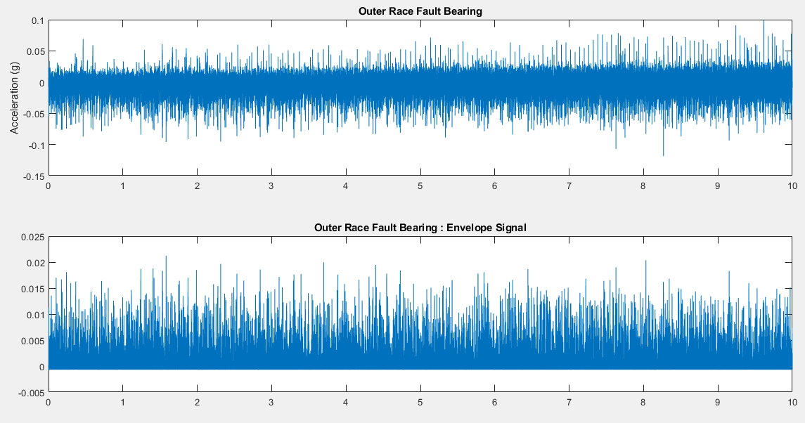

The envelope spectrum analysis of the vibration data of the outer race bearing fault. This procedure to detect outer race fault from the healthy bearing is not that applicable or practical as it is evident from the graphs that the

The envelope spectrum analysis of the vibration data of the healthy bearing is a procedure with which we can seclude the original vibration of the data from the surrounding noise data that may be accumulated in the results to contaminate the original data.

The graph below displays the waveform that we obtain after doing the envelope spectrum. It is clearly shown in the graph that no particular harmonics are present at either the BPFO or BPFI, it is a testimony that the bearing under consideration is a healthy one.

**Outer Race Fault, Bearing Vibration Analysis:**

Kurtosis Analysis:

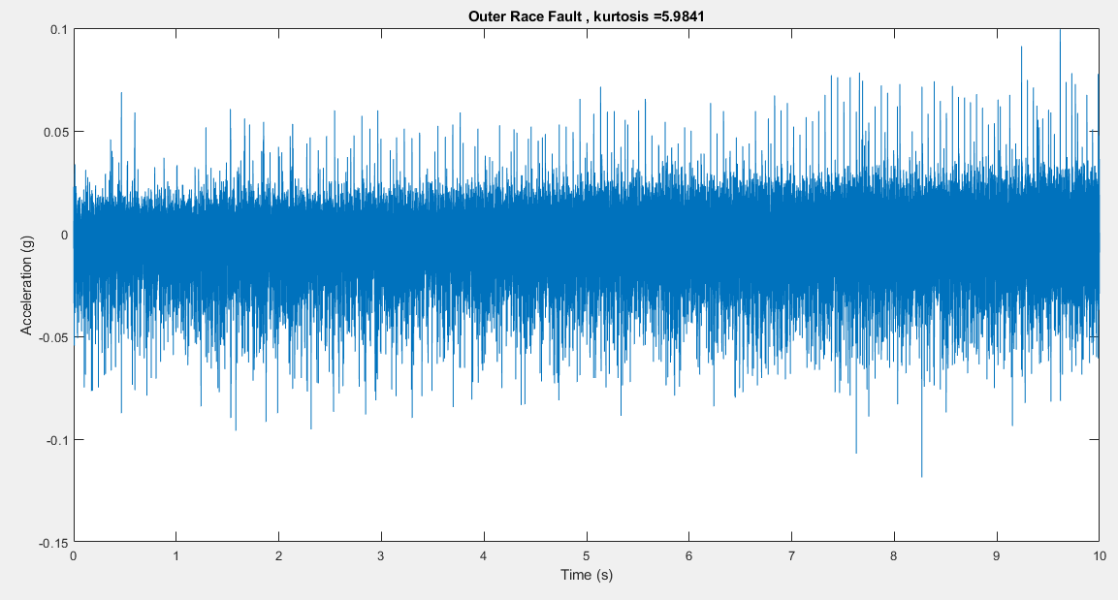

For an outer race fault signal, the amplitude modulation at BPFO is slightly noticeable, but it is masked by strong noise. The normal signal does not show any amplitude modulation. Extracting the impulsive signal with amplitude modulation at BPFO (or enhancing the signal-to-noise ratio) is a key pre-processing step before envelope spectrum analysis. The next section will introduce kurtogram and spectral kurtosis to extract the signal with highest kurtosis, and perform envelope spectrum analysis on the filtered signal.

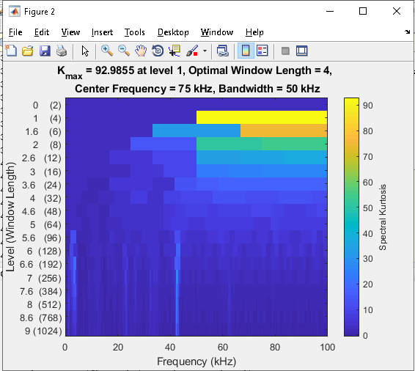

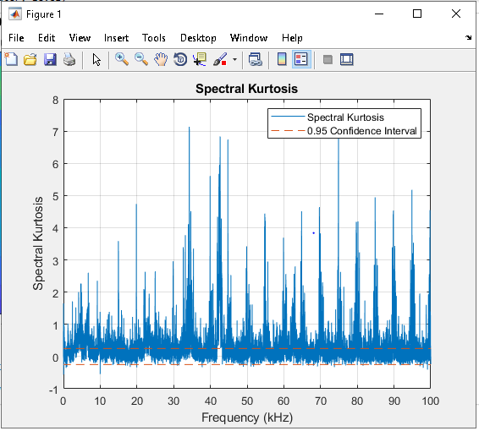

The image above represents the peaks that are unwanted or which are induced due to the fault in the bearing. As the bearing is faulty, the